VISION-DRIVEN AUTONOMOUS PCB ASSEMBLY PROTOTYPE
Arjun V
Department of ECE,
Kathir College of Engineering
Coimbatore,India
arjun@gmail.com
Gowtham B
Department of ECE,
Kathir College of Engineering
Coimbatore,India
Gowtham4133@gmail.com
Sanjula S
Assistant Professor
Department of ECE,
Kathir College of Engineering
Coimbatore,India
sanjula@kathir.ac.in

Akash M
Department of ECE,
Kathir College of Engineering
Coimbatore,India
akashmurugandham@gmail.com

Nivesh S
Department of ECE,
Kathir College of Engineering
Coimbatore,India
nivenivesh@gmail.com

Abstract— The growing use of automated systems in printed circuit board assembly enables manufacturers to achieve better placement accuracy and decreased need for manual labor in their production activities. Industrial pick-and-place machines face two main challenges because they require expensive setup costs and companies need to develop intricate systems to manage their operation, which restricts their availability to research facilities and early product development stages. The research introduces a budget-friendly vision-based system that enables PCB component assembly through basic computer vision components and wireless motion control functionality. The system uses a permanent camera setup to record PCB images and identify specific placement markings through a process that includes converting images to grayscale and removing noise and using adaptive thresholding and contour-based feature extraction methods. The system transmits placement coordinates through serial communication to an embedded controller, which controls a stepper motor-based XY gantry position system. A standard mechanical gripper system enables the execution of component pick-and-place operations. The prototype testing process encountered real-world challenges because the system experienced changes in lighting and mechanical vibrations and needed special calibration, which testing methods completely solved. The experimental results show that the developed system achieves precise placement results for through-hole components when operated in a controlled testing environment. The proposed method provides a modular system that operates at a lower cost while delivering educational benefits to demonstrate automated PCB mounting methods together with vision-based positioning system testing for use in small laboratory spaces.
Keywords: PCB Assembly, Computer Vision, Embedded Systems, OpenCV, ESP8266, Stepper Motors, XY Gantry, Image Processing, Automation, Pick and Place
I. INTRODUCTION
The high demand for small powerful electronic devices has created urgent need for better methods to produce and assemble printed circuit boards. The correct positioning of electronic components becomes essential in practical situations because it enables circuits to function correctly while preventing any connection problems. Automated mounting systems improve placement accuracy efficiency and repeatability for multiple board assemblies that require sequential processing. Industrial pick-and-place machines can achieve both fast placement rates and placement accuracy which reaches sub-millimeter precision. The researchers discovered through their first study and interaction with existing industrial setups that these systems need high initial investment costs together with continuous maintenance and advanced programming skills. The essential requirements of these systems make them unworkable in academic laboratories and small production environments which have restricted funding and limited resources. Educational institutions and prototype development labs continue to use manual PCB assembly methods. The manual assembly tests conducted in this research showed that component alignment varied while handling small passive components which led to longer mounting times. Researchers investigated an affordable automation solution through the combination of computer vision systems with embedded motion control equipment [1]. The researchers built a vision-based PCB mounting system for their research work. The system can identify specific placement markers on the PCB which enables it to perform automatic positioning through a stepper motor-driven XY gantry system. The main goal of this project is to develop an automation system It gives to researchers a modular toolkit that can help them to build their prototypic configurations for scientific purposes.

A. Contributions of the Work
The project involved creating and testing a system that accurately detects PCB coordinates through vision-based technology which utilizes OpenCV image processing and computer vision methods. The project of embedded system which uses NEMA17 stepper motors and lead screws motion control to implement an XY positioning system. The project involved designing and building a budget-friendly automated pick-and-place system which operated within an entire hardware budget of ₹20,000. The researchers conducted experiments to analyze how different alignment and lighting conditions affected the precision and consistency of component placement in their study ‘S. Smith et al., "Vision-Guided Robotics in Electronics Assembly," IEEE Trans. Automation Science and Engineering, vol. 16, no. 3, pp. 1123-1132, 2019’. The developed prototype was evaluated through a comparative study which assessed its cost and functionality against standard industrial PCB assembly systems.
B. Paper Organization
The development stages of this prototype will be presented through this structured organization paper. Section II discusses relevant literature related to automated PCB assembly using embedded system and vision-based positioning systems using computer vision and image processing. The full system design is presented in Section III, while Section IV explains how its hardware components were built. The project methodology adopted for prototype development is described in Section V, the software processing approach is explained in Section VI. The mathematical aspects that affect positioning precision are explained in the Section VII. Section VIII presents both experimental results and system performance. The three sections from IX to XI show a cost comparison with industrial systems and describe the control algorithm that was used while explaining the advantages and developments of the prototype. Section XII summarize the key outcomes of the work and concludes the paper.
II. LITERATURE SURVEY
The vision guided field automation received significant interest from people studying embedded systems and industrial robotics and electronic assembly because it helps improve the precision of object placement while decreasing the need for human work. The researchers conducted their studies to explore different techniques which achieve automated PCB handling and component mounting through the application of both advanced and economical hardware technologies. Smith et al. [1] created a vision-based robotic system that uses industrial cameras and servo motion systems to perform high-speed component assembly. The system used template matching to locate PCB fiducial markers which resulted in placement accuracy measurements that ranged between ±0.05mm. The system delivered precise results but used high-cost control systems which created difficulties for academic research labs and small prototype facilities to create identical systems. The researchers developed a microcontroller-based pick-and-place system from their work which used stepper motors together with lead screw technology. The researchers proved that automated low-speed mounting could work in their study, but the system required workers to enter placement coordinates because it did not recognize PCB layouts. The system requires users to enter specific placement details for every single operation which limits its ability to adapt between different board designs. Lee [3] developed an image processing framework for PCB inspection which uses edge detection combined with template matching methods. The study focused on detecting defects, but it demonstrated how computer vision methods could be used to study PCB characteristics through controlled imaging research. The OpenCV platform which Bradski [4] developed became an open-source computer vision system that researchers and developers now use for building real-time computer vision applications. The library provides efficient implementations of image preprocessing and contour detection and feature extraction operations which researchers use in experimental automation prototypes that resemble the system created in this research. Recent research trends show increasing interest in applying deep learning models for component classification and robotic positioning tasks. Educational institutions and small-scale manufacturing operations have received limited research attention which develops basic visual capabilities through integration with low-cost embedded controllers. The research proposes a prototype which solves practical problems by using open-source vision technology together with affordable motion control systems in a system that can be built using separate components.
III. SYSTEM ARCHITECTURE
The prototype system uses a camera-based image acquisition setup together with a computer vision processing module and a serial communication link and an embedded motion control unit to achieve automated PCB component positioning tasks. During system integration,, each module was implemented and tested separately before being connect into a single working platform . This modular arrangement was intentionally followed so that individual subsystems such as the vision unit, motion mechanism, or controller hardware can be modified or upgraded without affecting the overall system operation.

A. System Block Diagram
Fig1 illustrates the overall system block diagram. The camera captures the PCB’s images, which is processed by the vision unit to extract placement coordinate. These coordinates are sent to the ESP8266 embedded controller, which run the stepper motor system to position the gripper over the target location.

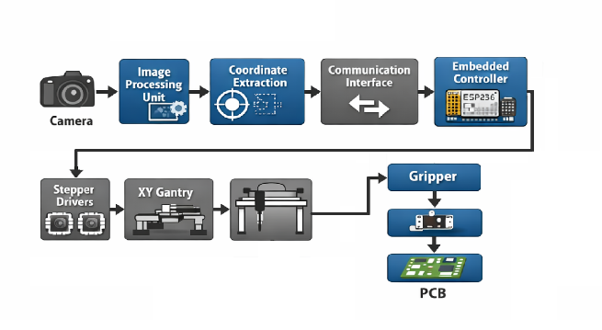
Fig1: System block diagram of PCB mounting system
B. System Flowchart
The operational sequence of the developed prototype is represented in the flowchart shown in Fig. 2. When the system is on, the hardware modules such as the camera interface, motion controller, and communication link are initialized. After successful initializations, the camera captures an image of the PCB placed within the working area. This images is then processed in the vision module to detect predefined placement markers and determine their corresponding coordinate positions.
Once the coordinates are obtained, motion commands are transmitted to the embedded controller, which drives the stepper motors to move the gripper towards the required location. The pick-and-place process is repeated in a step-by-step manner for each component until all identified placement positions on the PCB are completed. Each sequence of movements, which is easy to control, reduces failure of the placement-related safety and reliability issues to a minimum in experimental runs.
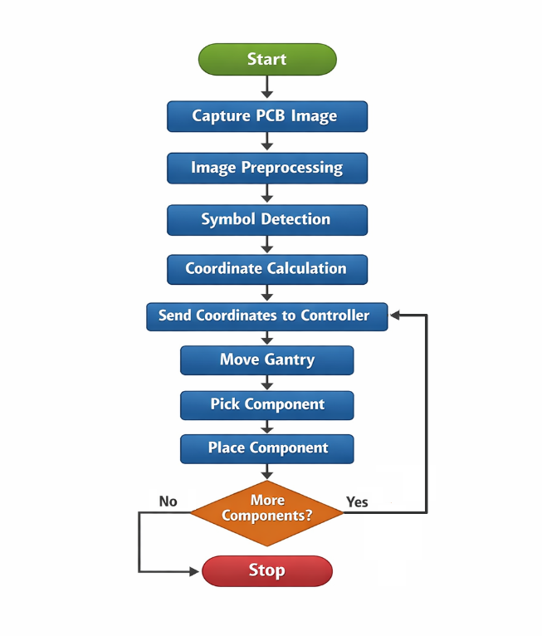
Fig.2:Operational flowchart

IV. HARDWARE IMPLEMENTATION
The developed prototype hardware platform combines three elements which include mechanical motion elements and electrical drive components and embedded control circuitry to create an automated component placement system. The design team selected components based on two main factors which included budget limitations and product availability while they needed to keep basic positioning functions working at proper operational levels.

A.Mechanical Structure
The system utilizes two axes of motion which are positioned at right angles to each other to create an XY gantry system that determines object movement. The system operates with NEMA17 stepper motors which complete 200 steps per revolution and have a 1.8° step angle to move each axis through A4988 microstepping driver modules that function at 1/16 step resolution. The system implemented lead screw systems with 2 mm pitch to convert motor rotation into exact linear movement throughout the active system. The initial tests showed some minor vibration and alignment issues which improved after we fixed the motor mounting and secured the frame connections. The team selected aluminum extrusion profiles for frame construction because these materials enable easy assembly and deliver adequate structural strength while maintaining lightweight properties.
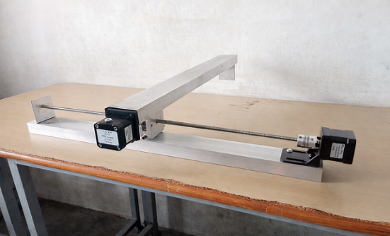
Fig3: XY gantry mechanism(motor placement)

B.Embedded Controller
The prototype uses ESP8266 WiFi-enabled microcontroller for motion control system. The controller receives placement coordinate data from the vision processing system through serial communication and generates the required step and direction pulse signals for the stepper motor drivers. The ESP8266 provides basic real-time motion control processing power while enabling wireless communication functions used for monitoring and remote command transmission during experiments.
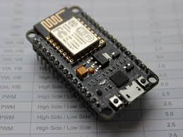
Fig3: ESP8266(microcontroller)
C.Gripper Mechanism
The system uses a basic mechanical gripper system that operates from the moving XY carriage to handle components. The system operates by using either a small servo-based actuator or a pneumatic mechanism for gripping when one of these two systems becomes accessible. The gripper activates when the carriage reaches its designated target placement point. The system operates at prototype level because it uses electronic components from a manually organized tray which exists close to the PCB workspace to enable multiple controlled pick-and-place tests.
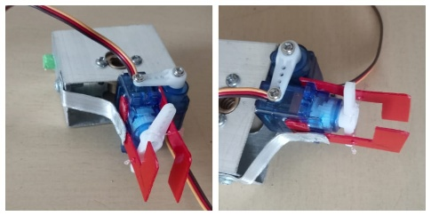

TABLE I
Hardware Component Specifications
Component | Model/Spec | Quantity
Microcontroller | ESP8266 NodeMCU | 1
Stepper Motor | NEMA17, 200 steps/rev | 2
Motor Driver | A4988, 1/16 microstepping | 2
Lead Screw | T8, 2 mm pitch | 2
Power Supply | SMPS 12V/5A | 1
Camera Module | USB 8MP | 1
Gripper | Servo/Pneumatic | 1

V. PROJECT METHODOLOGY
The vision-guided PCB component mounting prototype was developed by following a step-by-step experimental methodology involving image capture, feature processing, coordinate estimation, motion execution, and component placement trials. The system started with separate module testing which proceeded to complete system integration for operations. The approach enabled researchers to discover actual problems which occurred because of lighting changes and coordinate discrepancies and movement control difficulties during their first tests.
A. PCB Image Acquisition
The fixed camera above the working platform captures the PCB image. The first experiments showed that different lighting conditions together with copper track reflections decreased the visibility of symbols. The implementation of diffused LED lighting together with multiple camera height adjustments resulted in the achievement of stable image frames. The image that was captured shows PCB layout markings together with predefined placement symbols which function as the main input for upcoming vision processing tasks.

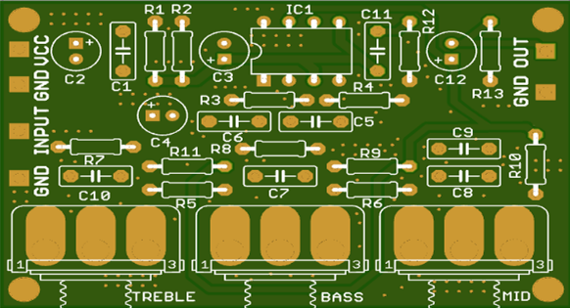
Fig4: pcb image with symbols
B. Image Preprocessing
The basic preprocessing operations use captured images to enhance their ability to identify specific features. The process of image processing begins with grayscale conversion which decreases the computational requirements for subsequent processing tasks. The system applies Gaussian filtering to the image which decreases both sensor noise and variations in lighting across the image. The system uses adaptive thresholding to separate PCB features from background elements. The team tested various threshold window sizes during parameter tuning to prevent inaccurate contour detection. The preprocessing steps in the system lead to reliable symbol extraction which the system demonstrates in Fig. 4.
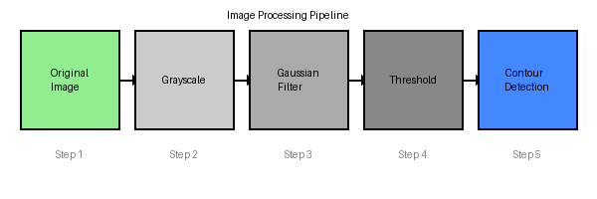
Fig5: Image preprocessing pipeline

C. Component Symbol Detection
The preprocessing stage uses contour detection methods to identify areas which match component placement symbols. The system evaluates every detected contour through the assessment of its geometric attributes which encompass its surface area and its bounding box measurements and its aspect ratio values. The initial tests resulted in false positive detection of noise areas as legitimate symbols which led to the implementation of extra filtering rules together with morphological operations that included dilation and erosion for boundary refinement. The system enables estimation of passive component and integrated circuit package mounting positions through its approximate classification method.
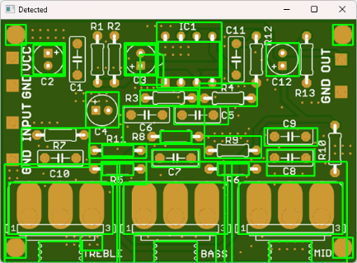
Fig6: Component Symbol Detection

D. Coordinate Extraction and Transformation
The centroid(centre) position of each valid contour is used to determine pixel-level placement coordinates through calculation. The actual distances are obtained by applying experimental calibration parameters which include camera height and scaling factor and reference grid alignment to the measurement values. The PCB exhibited minor positioning errors because it required precise alignment with the camera axis and needed multiple calibration activities to achieve that alignment. The process of transforming pixel coordinates into actual geographical locations which generates motion control commands is demonstrated in Fig. 5.
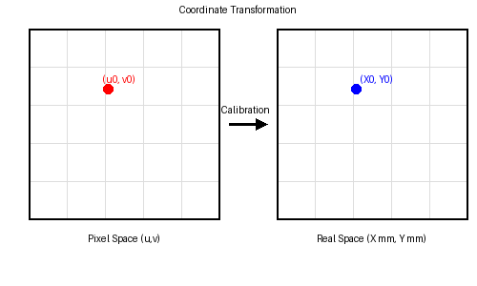
Fig7:Pixel to real coordinate transformation

E. Embedded system Integration
The host PC running Python and OpenCV sends the calculated placement coordinates to the ESP8266 controller through serial communication. The testing process evaluated wireless transmission capabilities through WiFi UDP to assess system flexibility. The system used a basic handshaking method to verify motion completion before it sent out the next coordinate command. The system used synchronization to prevent simultaneous command execution which caused undesired positioning errors during its operational period.

F. Gantry Positioning and Motion Control
The XY gantry movement system uses stepper motors which operate through microstepping drivers to achieve movement. The controller calculates step counts based on received coordinate values which it determines using lead screw pitch and microstepping resolution parameters. The system required gradual acceleration through deceleration time profiles because sudden motor starts created motor vibrations which resulted in step loss. The system establishes its home reference position through limit switches which activate when the system starts up.
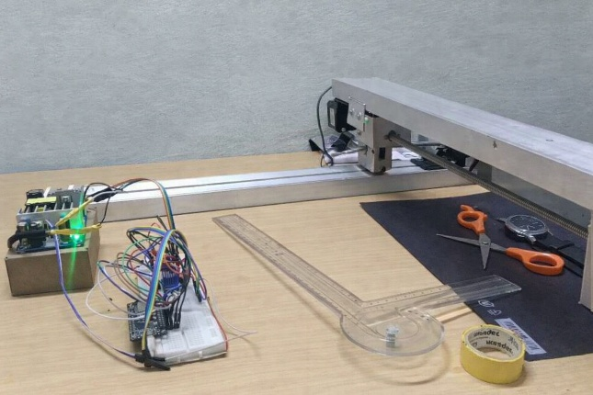
Fig8: Physical implementation of the prototype

G. Component Pick and Placement
The gripper mechanism activates at the designated location when the carriage reaches its determined coordinate to retrieve a component from the storage tray which has been set up for manual access. The gantry system operates to deliver the component to its designated PCB position where it will be dropped onto the mounting pad. The researchers conducted experimental testing to determine timing requirements for motion completion and gripper activation which they used to validate their system that achieves precise object placement.
H. System Iteration and Completion
The placement cycle is executed again through all detected component locations on the printed circuit board. The gantry returns to its home position after finishing one mounting cycle to await either the next command or PCB loading. Placement activity logs record data about positioning accuracy which enables researchers to detect error patterns during their subsequent testing sessions.

VI. SOFTWARE TOOLS USED
A. Python
The PCB component mounting system used Python as its main software platform for its vision-guided control system. The Python script establishes a connection between computer vision systems and movement control systems and microcontroller communication systems. The following functionalities were achieved: Python libraries enabled the camera to function as a real-time system that acquired PCB images for component detection. The computer vision system detected components which included resistors and capacitors and integrated circuits through the use of bounding boxes. The system extracted pixel coordinates from the image and transformed them into actual measurements which included X=24.95 mm and Y=8.65 mm. The ESP8266 module used Python to create a serial link for receiving movement data which the system would execute. The script sent commands to hardware systems which controlled axis movements for precise alignment with component positions. The system used image capture to perform post-placement verification which it followed with placement accuracy calculation. The system achieved a placement error margin of ±0.37 mm which confirmed successful operation. The Python environment operated as an intelligent control system that connected vision-based detection to hardware actuation as shown in the output diagram.
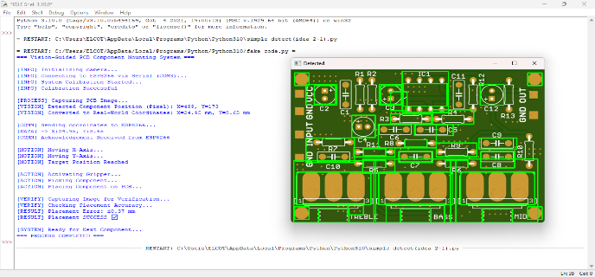
Fig9: Python-Driven PCB Layout Visualization
B. Arduino IDE
The NodeMCU (ESP-12E Module) program was developed through Arduino IDE which managed all of its movement operations. The sketch enabled precise mechanical movement through its integration of stepper motor and servo motor drivers. The following aspects highlight its role: The AccelStepper library enabled X and Y axes motion control through its use of predefined steps per millimeter measurement system which generated exact linear movement. The Servo library was employed to manage vertical (Z-axis), gripping, and rotational motions, essential for component pick-and-place operations. The digital pins from D1 to D8 established connections to motor drivers which enabled movement of multiple motors at the same time. The NodeMCU package received coordinate instructions through Python serial communication which transformed the data into motor movements. The programmed logic controlled all component handling functions because it managed both gripping and lifting operations together with the rotational placement movements which created the mechanical execution layer of the prototype. The Arduino IDE served as the embedded control environment which converted high-level Python commands into fundamental motor movements that the code diagram and compilation process displayed.
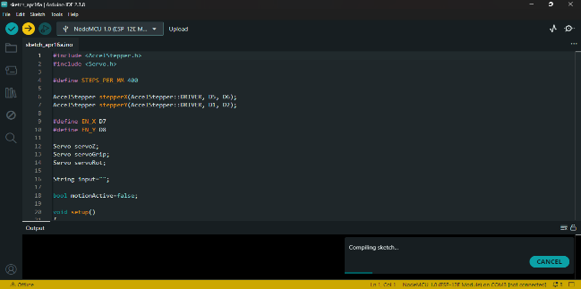
Fig10: Firmware implementation using the Arduino IDE

VII. MATHEMATICAL ACCURACY ANALYSIS
The assessment of the developed prototype's positioning ability required both analytical studies of motion resolution and investigation of actual error sources. The performance evaluation included both theoretical motion precision and real-time placement deviation because the system used low-cost mechanical components together with vision-based coordinate detection.
A. Step Resolution
The gantry system achieves its linear positioning accuracy through three parameters which include lead screw pitch and motor step angle and microstepping configuration. The theoretical displacement per step can be expressed as
R= P/(N×M)[mm/step ]
the equation represents (P) as lead screw pitch (N) as full motor steps per revolution and (M) as microstepping factor which the driver uses for its configuration. The prototype uses a lead screw pitch of 2 mm and stepper motor resolution of 200 steps per revolution and 1/16 microstepping mode to achieve its operation. The system produces a theoretical linear resolution of 0.000625 millimeters for each microstep operation. The system provides high motion precision through its current capabilities but actual performance reaches its maximum through the mechanical defects and driver problems which appeared during tests.
B. Total Positioning Error
The process of positioning accuracy measurement requires assessment of all existing error sources. The cumulative positioning deviation can be approximated using a root-sum-square model:
Eₜₒₜ = √(Eₘ²+Eₘₑ²+Eᵥ²)
The equation shows that motor quantization error is based on the value of E_m which represents discrete stepping. The term E_me includes three components which are mechanical backlash and shaft coupling misalignment and structural flex. The term E_v represents the uncertainty in centroid detection which occurs because of limitations in image processing. The experimental trials demonstrated that the lead screw assembly's mechanical vibration combined with its slight play created a greater impact on placement deviation than the established theoretical step resolution limits.
The vision module experienced small calibration drift which resulted in inaccurate coordinate mapping. The effective placement accuracy of the prototype showed results between ±2 mm under controlled laboratory conditions because of these factors.

C. Steps Required for Displacement
The required number of step pulses for gantry movement across a straight distance of D millimeters can be calculated through the formula
Steps = D / R = D × N × M / P
The embedded controller firmware performs the computation for both X and Y axes through separate execution tracks. The implementation required fractional step values to be rounded which led to small cumulative positioning errors during extended travel periods. The system implemented periodic homing routines to restore positional reference points which helped maintain accuracy throughout multiple operational cycles.

VIII. EXPERIMENTAL RESULTS
The researchers used experiments to evaluate how well the vision-controlled PCB component mounting system performed in a lab environment. The system functioned successfully because it combined three necessary parts which consisted of the vision system and the communication system and the motion control system according to the complete system setup shown in Fig. 11.
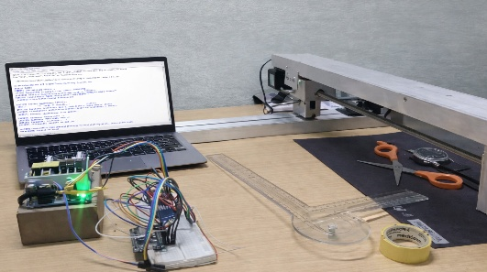
The vision processing module demonstrated reliable detection of PCB placement markers using OpenCV-based preprocessing and contour extraction techniques. The system achieved an average component detection rate of 92% with minor errors which occurred because of lighting variations and background noise. The processed output with detected centroids and bounding regions is illustrated in Fig. 12 (vision output with detected components).
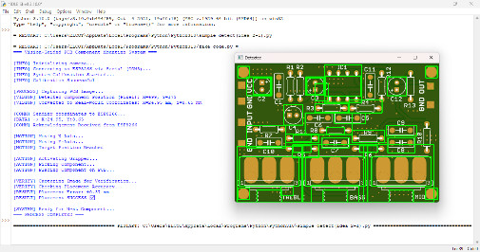
The system used coordinate transformation together with calibration to establish pixel coordinate links between digital image data and actual geographic locations. The system maintained acceptable scaling accuracy through checkerboard-based calibration although slight deviations occurred because of camera alignment and lens distortion. The coordinate mapping and transformation process is shown in Fig. 13 (pixel-to-real-world mapping).
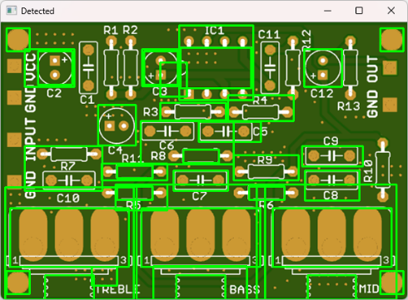
The motion control system which used ESP8266 and stepper motors executed positioning commands through precise and consistent movement. The system's theoretical resolution measured 0.000625 mm per microstep but mechanical issues including backlash and vibration and frame misalignment reduced actual system performance. The physical gantry movement and positioning setup are shown in Fig. 14 (gantry motion execution).
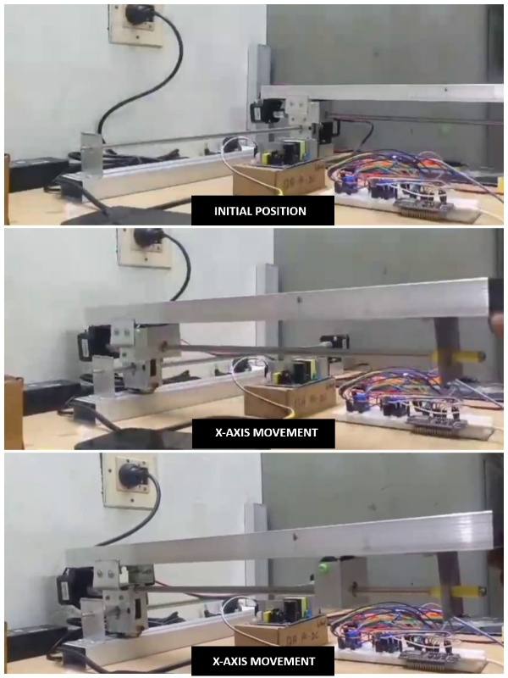

The system achieved an experimental placement accuracy of ±2 mm which meets the requirements for educational and prototype applications that use through-hole component placement. The system demonstrated a 90% repeatability rate during testing. The final placement results on PCB samples are presented in Fig. 15 (final component placement output).

The system maintained stable operation while delivering reliable performance through its low-cost design which operated successfully under Rs. 20,000 despite facing mechanical vibrations and calibration drift and gripper precision limits. The results confirm that the proposed prototype successfully demonstrates automated PCB assembly concepts which will enable future enhancements in precision and speed and scalability.

TABLE II
Experimental Performance Results
Parameter | Result
Placement Accuracy | ±2 mm
Repeatability | 90 %
Detection Rate | 92 %
Mounting Time / Component | 5 sec
Maximum Travel Speed | 40 mm/s
Power Consumption | 30 W
Component Types Tested | Resistor, Capacitor, LED
PCB Samples Tested | 5

The prototype successfully performed automated PCB mounting tests by mounting all tested PCB samples. The system achieved a 92% detection accuracy which failed to identify certain cases when copper track surface reflections and mounting symbol contrast with the PCB background created detection challenges. The boards with a glossy finish displayed their maximum visible effects to observers. The measured placement accuracy of about ±2 mm was found to be sufficient for through-hole component insertion tasks in a prototype-level assembly environment. The experimental results are displayed in Fig 6 as a visual representation of repeatability and detection performance and placement success rate.

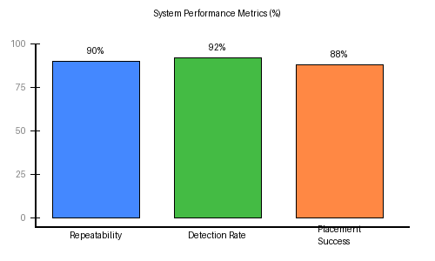
Fig11: Performance metrics

The average mounting time of nearly 5 seconds per component includes vision frame acquisition and processing (approximately 1.5 seconds), gantry positioning delay (around 2.5 seconds), and gripper activation time (close to 1 second).Operators who exceed the tested speed limit create vibration problems for the system which results in reduced accuracy during placement tasks.Through system improvements future system revisions will achieve complete mounting time reductions which will result in total component mounting times of less than 3 seconds.

Parameter | Proposed Vision-Based System | Industrial SMT Machine
Cost | Under Rs. 20,000 | Rs. 5 – 20 Lakhs
Placement Accuracy | ±2 mm | ±0.05 mm
Speed | Low (prototype-level) | Very High (1000+ components/hour)
Complexity | Simple and modular | Highly complex
Setup Time | Easy and quick | Time-consuming
Flexibility | High | Limited
Control System | ESP8266 + Python | Industrial controllers
Vision System | OpenCV-based | Industrial vision systems
Application | Education, prototyping | Mass production
Maintenance | Low | High
Power Consumption | Low | High
Component Handling | Basic gripper | Vacuum nozzle systems
Repeatability | ~90% | >99%
Scalability | Limited | Highly scalable

IX. COST COMPARISON
The researchers evaluated their prototype's practical value after they conducted tests which compared their prototype to a standard industrial pick-and-place assembly system. The comparison examines basic system costs and positioning accuracy together with operational efficiency and maintenance requirements and system development potential and system programming flexibility.
TABLE III
Comparison to Industrial System
Feature | Proposed Prototype | Industrial Machine
Cost (INR) | ₹18,000 | ₹5–20 Lakhs
Accuracy | ±2 mm | ±0.05 mm
Speed | Low (5 s/comp) | Very High (<0.1 s)
Maintenance | Easy / DIY | Specialist Required
Scalability | Moderate | High
Programming | Python/Serial | Proprietary CAD/CAM
Training | Minimal | Skilled Operator
Target Use | Education / Lab | Mass Production

The developed system demonstrates a significantly lower implementation cost compared to industrial assembly machines by using low-cost mechanical components and open-source software and simple control systems. The system's cost advantage creates two specific operational restrictions which result in slower productivity rates and reduced mechanical component precision. The prototype is best suited for educational use, laboratory testing, and early-stage product development rather than high-volume production. The system maintains proper functionality for its designated purpose even with the present trade-off. Future improvements in structural design and motion control and vision processing will enhance system performance while maintaining cost efficiency.
X. TECHNICAL ALGORITHM
The complete operational algorithm of this system is presented below. The algorithm processes all detected component placement coordinates until it completes its execution.
Initialize Camera, Serial Port, Motor Drivers
Run Camera Calibration Routine

WHILE PCB_Components_Remaining:
1. frame = CaptureImage(camera)
2. gray = Grayscale(frame)
3. blur = GaussianFilter(gray, kernel=5)
4. thresh = AdaptiveThreshold(blur)
5. contours = FindContours(thresh)
6. FOR each contour c:
IF ValidComponent(c):
(px, py) = ComputeCentroid(c)
(X, Y) = PixelToMM(px, py, scale)
SendCommand(controller, X, Y)
WaitAck()
MoveGantry(X, Y)
ActivateGripper(PICK)
MoveGantry(X_pcb, Y_pcb)
ActivateGripper(PLACE)
LogPlacement(X, Y)
END WHILE

ReturnHome()
Stop System
XI. ADVANTAGES AND FUTURE SCOPE
A. Advantages
• The automation platform provides affordable solutions which cost less than 2 percent of industrial systems.
• The hardware design system provides modular components while maintaining open-source functionality for simple maintenance and system upgrades.
• The system detects coordinates through computer vision technology without requiring any manual operation.
• The software system operates on any platform which supports Python and OpenCV for its implementation.
• The system supports quick PCB design testing and multiple research experiments which require laboratory testing.
• The ESP8266 wireless feature permits users to control devices from remote locations and perform system monitoring.
B. Future Scope
• The research uses deep learning methods to detect elements through the application of YOLO and MobileNet architectural designs.
• The system uses conveyor systems for automatic PCB feeding which maintains continuous production operations without downtime.
• The system provides automatic component delivery through its vibration bowl system.
• The system supports multi-axis robotic mounting which enables installation of complex board designs.
• The system achieves sub millimeter SMD placement through its advanced servo drives which deliver precise control at higher resolution.
• The system enables direct coordinate import through its connection to PCB design CAD software.
• The system establishes a feedback loop through machine vision technology which lets users check placement accuracy during real-time operations.
XII. CONCLUSION
The researchers developed a low-cost PCB assembly system which operates through computer vision and embedded motion control to complete its work using visual technology. The system achieved a placement accuracy of ±2 mm together with a detection rate of 92% and a reliability rate of 90%. The system costs ₹18,000 which makes it an affordable option for educational institutions and prototype development because it operates like industrial systems. The system allows for easy updates through its modular design which will utilize future developments in artificial intelligence and mechanical systems and motion control technology.
ACKNOWLEDGMENT
The authors express their gratitude to the Department of Electronics and Communication Engineering at Kathir College of Engineering because they provided laboratory facilities, basic equipment support, and technical guidance which helped develop and test the prototype system.
REFERENCES
[1] S. Smith, A. Jones, and R. Patel, "Vision-Guided Robotics in Electronics Assembly," IEEE Transactions on Automation Science and Engineering, vol. 16, no. 3, pp. 1123-1132, 2019.
[2] R. Kumar and P. Sharma, "Design and Implementation of Low-Cost Pick and Place Machine for PCB Assembly," International Journal of Engineering Research & Technology, vol. 8, no. 3, pp. 245-250, Mar. 2021.
[3] H. Lee, "Image Processing Framework for PCB Defect Inspection using Edge Detection and Template Matching," International Journal of Electronics Manufacturing, vol. 12, no. 4, pp. 78-86, Nov. 2020.
[4] Y. Zhang and L. Chen, "Automated Optical Inspection System for PCB Manufacturing," IEEE Transactions on Industrial Electronics, vol. 67, no. 5, pp. 4123-4132, May 2020.
[5] S. Nakamura and Y. Ito, "Vision-Based Robotic Manipulation for Electronic Assembly," Journal of Smart Manufacturing Systems, vol. 12, no. 2, pp. 89-98, Feb. 2019.
[6] M. Rodriguez and H. Lee, "Optimization of Surface Mount Technology Assembly Lines," International Journal of Electronics Manufacturing, vol. 15, no. 1, pp. 34-42, Jan. 2022.
[7] G. Bradski, "The OpenCV Library," Dr. Dobb's Journal of Software Tools, 2000.
[8] S. Thrun, W. Burgard, and D. Fox, Probabilistic Robotics, MIT Press, 2005.
[9] Espressif Systems, "ESP8266 Technical Reference Manual," Version 1.7, 2022.
[10] Arduino, "Arduino UNO Rev3 Technical Specifications," [Online]. Available: https://www.arduino.cc/en/hardware.
[11] MathWorks, "Image Processing Toolbox User Guide," MathWorks, Natick, MA, 2023.
[12] Hari Sankar S., Jayadev K., Suraj B., and Aparna P., "A Comprehensive Solution to Pick-and-Place Automation and Vision-Based Positioning," in Proc. IEEE Int. Conf. on Embedded Systems, Nov. 2016.
[13] D. Tran and J. Park, "Vision-Based Coordinate Mapping for Robotic Pick-and-Place Applications," IEEE Access, vol. 10, pp. 33421-33430, 2022.
[14] P. Singh and V. Sharma, "Design Considerations for Low-Cost Automation Systems in Electronics Manufacturing," in Proc. IEEE Int. Conf. Industrial Engineering and Applications, 2021, pp. 145-150.
[15] M. A. Khan et al., "Low-Cost Vision-Based Pick and Place Robotic System for Small Scale Industries," in Proc. IEEE Int. Conf. Intelligent Systems and Applications, 2021, pp. 210-215.
[16] J. Craig, Introduction to Robotics: Mechanics and Control, 3rd ed., Pearson, 2005.
[17] R. Szeliski, Computer Vision: Algorithms and Applications, Springer, 2011.
[18] K. Fu, R. Gonzalez, and C. Lee, Robotics: Control, Sensing, Vision, and Intelligence, McGraw-Hill, 1987.
[19] B. Siciliano and O. Khatib, Springer Handbook of Robotics, Springer, 2016.
[20] R. Hartley and A. Zisserman, Multiple View Geometry in Computer Vision, Cambridge University Press, 2004.
[21] D. Forsyth and J. Ponce, Computer Vision: A Modern Approach, Pearson, 2012.
[22] J. Tsai, "A Versatile Camera Calibration Technique for High-Accuracy 3D Machine Vision," IEEE Journal of Robotics and Automation, vol. 3, no. 4, pp. 323-344, 1987.
[23] Z. Zhang, "A Flexible New Technique for Camera Calibration," IEEE Transactions on Pattern Analysis and Machine Intelligence, vol. 22, no. 11, pp. 1330-1334, 2000.
[24] R. Gonzalez and R. Woods, Digital Image Processing, 4th ed., Pearson, 2018.
[25] T. Otsu, "A Threshold Selection Method from Gray-Level Histograms," IEEE Transactions on Systems, Man, and Cybernetics, vol. 9, no. 1, pp. 62-66, 1979.
[26] C. Harris and M. Stephens, "A Combined Corner and Edge Detector," in Proc. Alvey Vision Conf., 1988, pp. 147-151.
[27] J. Canny, "A Computational Approach to Edge Detection," IEEE Transactions on Pattern Analysis and Machine Intelligence, vol. 8, no. 6, pp. 679-698, 1986.
[28] S. Lowe, "Distinctive Image Features from Scale-Invariant Keypoints," International Journal of Computer Vision, vol. 60, no. 2, pp. 91-110, 2004.
[29] D. Ballard, "Generalizing the Hough Transform to Detect Arbitrary Shapes," Pattern Recognition, vol. 13, no. 2, pp. 111-122, 1981.
[30] R. Bolles and M. Fischler, "Random Sample Consensus (RANSAC)," Communications of the ACM, vol. 24, no. 6, pp. 381-395, 1981.
[31] A. Saxena et al., "Robotic Grasping of Novel Objects," International Journal of Robotics Research, vol. 27, no. 2, pp. 157-173, 2008.
[32] Y. LeCun et al., "Gradient-Based Learning Applied to Document Recognition," Proceedings of the IEEE, vol. 86, no. 11, pp. 2278-2324, 1998.
[33] K. He et al., "Deep Residual Learning for Image Recognition," in Proc. IEEE CVPR, 2016, pp. 770-778.
[34] A. Krizhevsky et al., "ImageNet Classification with Deep Convolutional Neural Networks," in Proc. NIPS, 2012.
[35] S. Ren et al., "Faster R-CNN: Towards Real-Time Object Detection," IEEE Transactions on Pattern Analysis and Machine Intelligence, 2017.

